

**UNIVERSITY OF PETROLEUM AND ENERGY STUDIES**

**School of Computer** **Science**

**2020-21**

**GRAPHICS AND ANIMATION TOOLS LAB**

**Faculty: Dr. DURGANSH SHARMA**

**Assistant Professor**

**Department of Cybernetics.**

**School of Computer Science, UPES**

**Submitted By:**

**Name- Ishita J Karmakar**

**Roll no-R100217107**

**Batch-B3**

**Semester- 7**

**Course-B.Tech CSE-OSOS**

**SAP ID- 500064067**

**EXPERIMENT NO 6**

**Aim** :- Design a 3D Hut using Blender.

**Objective** :- To Design a 3D Hut using features of Blender 2.8.

**STEPS TO MAKE DESIGN A 3D HUT: -**

1. Open Blender workspace delete the existing cube and Click on the add option and add cylinder.
2. Then we will make some adjustments in the cylinder like radius and depth, we will set the depth and radius as 2m and set cap fill type to nothing.
3. After making changes in the cylinder we will select the upper face of cylinder and then extrude it.
4. After the above step we will shape that extruded region like the upper part of the hut using scale option.
5. For creating a door, we are going to select any front face of the cylinder and then delete it using X key.
6. For creating the structure of tomb of the hut, I have added some more mesh like Torus and Ico Sphere.

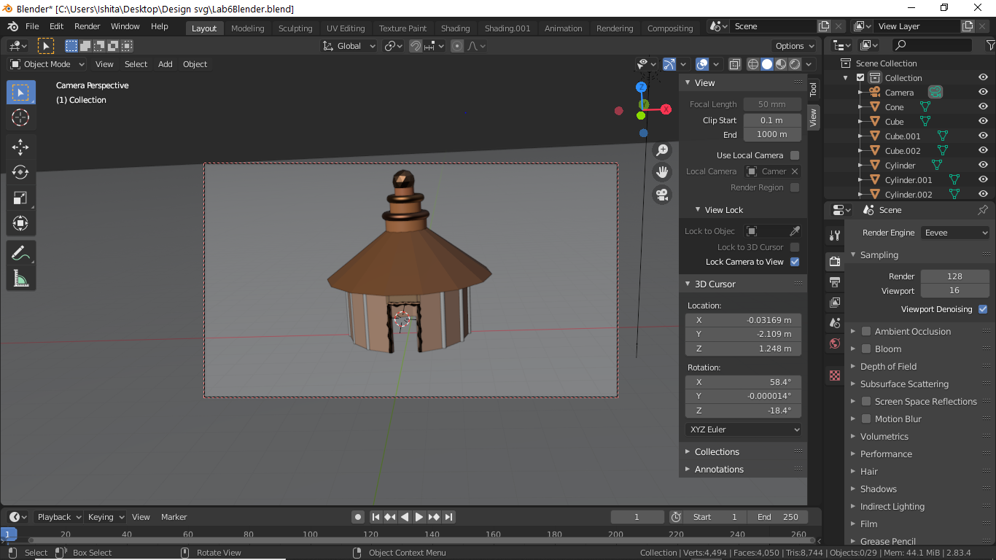

1. To give hut a realistic effect we will add the texture on it by going in the shading section and selecting the image that we will download from the internet. Then drag it and connect it to the base color of the object properties.

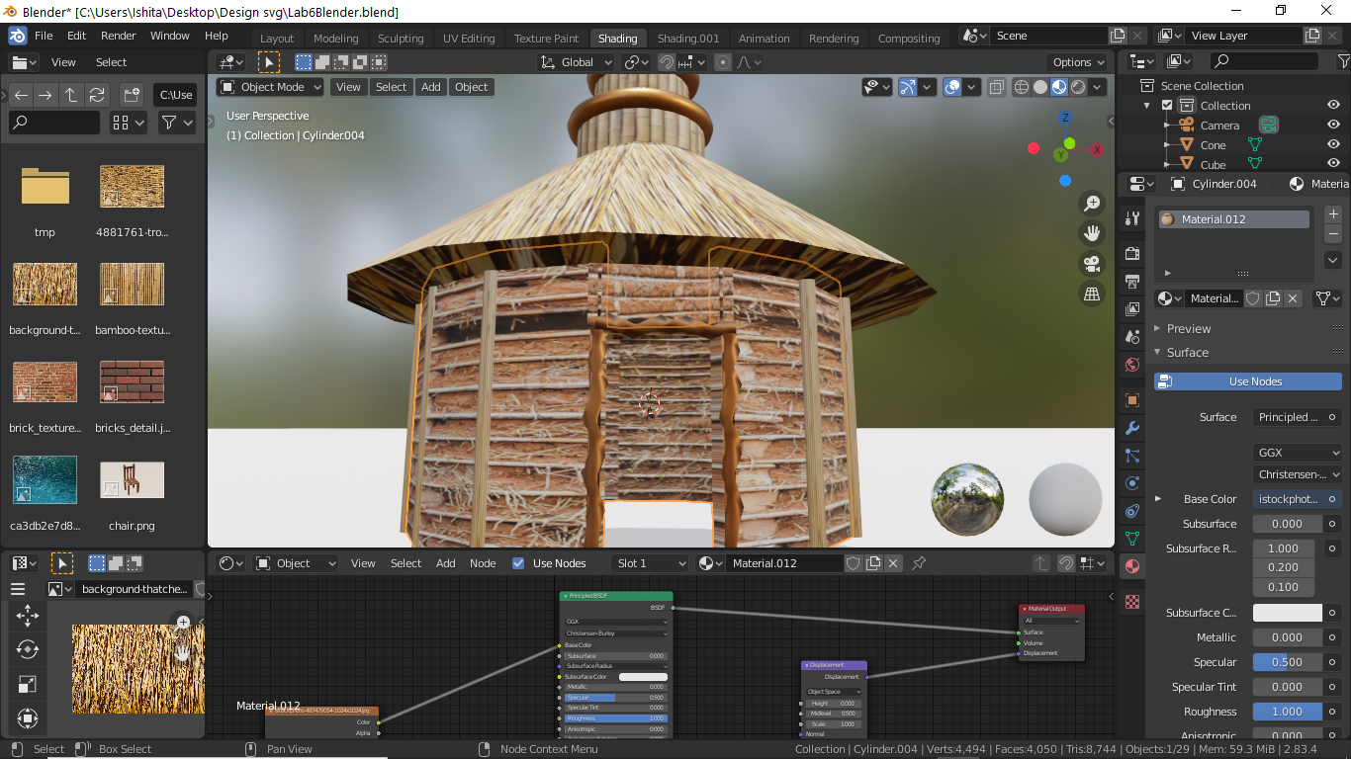

1. Now render the image to get a final result by setting the camera and light in proper position.

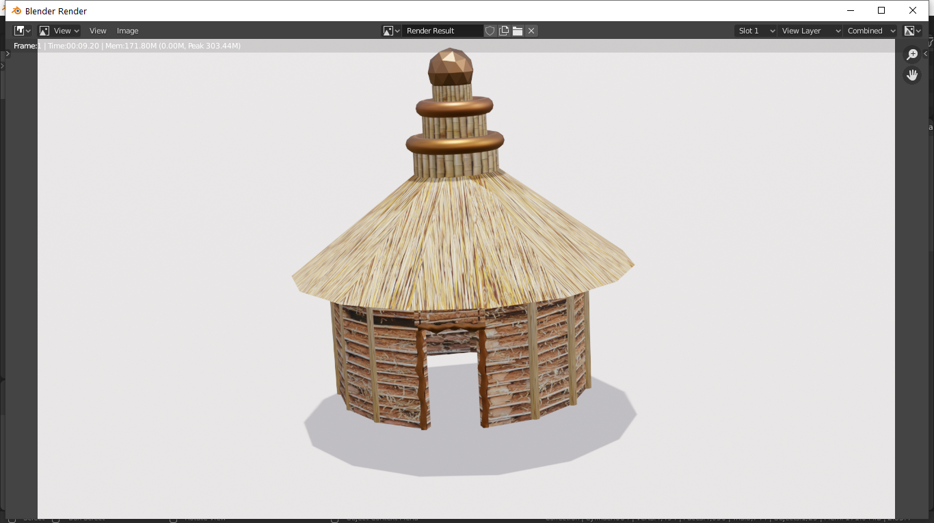

Link for Google Drive: - <https://drive.google.com/drive/folders/1p-sEQCZHlPDrL6KL5HmthqWHdQK65QMd?usp=sharing>